Tercer Cuerpo

Technical requirements

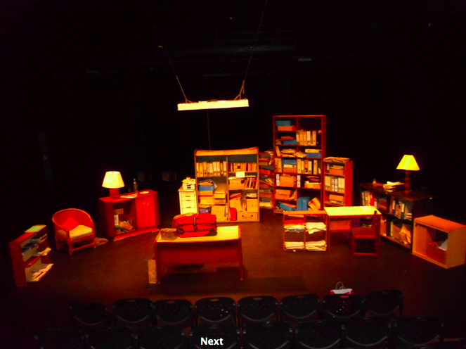

Furnitures - scenography

It´s necessary the festival send photographies of the elements in order TIMBRE 4 give the confirmation that is OK.

The scenography is composed of indoor furniture, related both office and house ones.

The following measures are expressed in centimeters (wide, deep and hight)

1) 1 short furniture with two wooden doors. (88cm x40cm x 76cm).
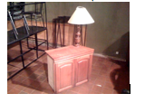
2) 1 wooden square shelf (old appearance) (84cmx20cm x 75 cm).

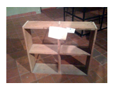
3) 1 stool (for one person, no back necessary. It´s not necessary that be of the colour of the photography ) (47cm high)

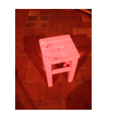
4) 1 office desk, with a metal cover (1.40cm x 64cm x 76 cm).
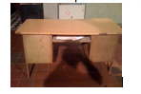
5) 1 short furniture with drawers by the side at left (these can be false ones, adding 3 wood pieces according to the size) (180 cmx 45 cm x 90cm).

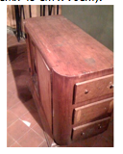
6) 1 office desk, wooden (50cm x99cm x75 cm).
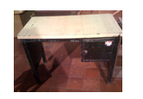
7) 1 armchair of wicker for one person (54cm de alto). With a pillow at its base

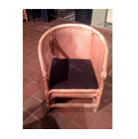
8) Different old library furniture that are at the depths of the space, like in the picture
(The higher could be of 200cm hight x 163 wide x 50 deep).

9) 1 old library of ash Green color (120 cm high x 200 cm long x 36 cm deep).

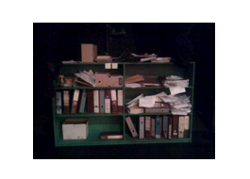
10) 2 old lamps (home like appearance). They should be connected to dimmers to control them.

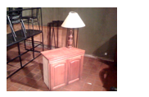

11) 1 recessed lighting fixture with 2 tubes fluor style of low consume. They will go hanged from the ceiling of the lighting grill, and connected to the dimmers console.
The grill form covering the tubes, as shown in the picture, is essential to the correct intensity of the light. It´s necessary that they are proper set in order to dirstribute the light spot and properly (not to the audience)
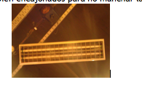

12) 1 office armchair with wheels.
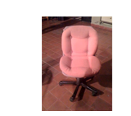

13) 1 wooden chair
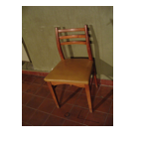

14) 4 wooden chairs of black color, very neutral. The actors sit down on them when they are no at stage.

Props
Props are all related to office objetcs, better if they are old, old boxes, folders, papers,newspapers, common books, telephonic old guides, not useful elements of office. They all should show the pass of time. A lot of material is required, nothing is necessary to be bought.
Please don´t hesitate to consult in case of doubts.

Aprox
- 40 librarian folders.
- 30 boxes to paper sheets A4 size
- 100 folders of cardboard
- 40 notebooks (of any kind, new, old ones)
- 30 common folders (better if they are old)
- Printed papers, sheets, rubbish material
- Office elements used or news such as: 25 pens,50 envelopes, 50 books of different sizes, magazines and newspapers of all types, files, 4 staplers, all what can be added
-1 traditional write typing .
-2 bottles of instant coffee.
-2 Telephones .
-2 key chain (with a bunch of keys) all ringed.
-1 box of Brown paper.
-A square pillow of 50cm x 50cm.
-1 big towel
-1 small towel

Every presentation, we need:
1 package of water biscuit
100 gr. Of cooked ham (for sandwich)
8 small bottles every day of presentation
1 big bottle
1 dyieng of hair in aerosol black color, or dark Brown. (Should be washable). One is used every presentation. Please consult in case of doubt

Lighting
See enclosed detailed of lighting

Observations: 2 recessed lighting fixtures are required, with 2 tubes fluor style of low consume. They will go hanged from the ceiling of the lighting grill, and connected to the dimmers console.
The grill form covering the tubes, as shown in the picture, is essential to the correct intensity of the light. It´s necessary that they are proper set in order to dirstribute the light spot and properly (not to the audience)

THEY SHOULDN´T BE DIGITALS OR WITH A BALLAST ELECTRONIC
IT´S NEEDED THAT BLINK , THEN OLD TYPE OF SWITCH ON, FOR FLICKERING EFFECT. IT´S N 12 OF THE REQUESTED SCENOGRAPHY

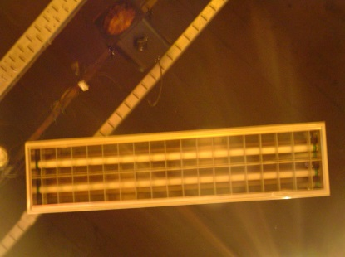

REGULATION: 48 channels. 2 KW by channel
Table of regulation able to be programmed: All the material must have their respective accessories, such as filter holders, chain of security…etc.
The colour filters are provided by the company TIMBRE 4

Space and minimal requirements:

Width: 7 m.
Depth. 6 m.
Hight : 5 m.
Black painted box/scene
Exit at the back of the stage to be able to put aerosol dyer on the hair of the actor without being Heard by the audience

Sonido (It depends on the space provided, please consult to see details)
4 ambient microphones.

Stuff that should be provided by the event
2 Load and unload
1 Engine expert
2 Lighting technician
1 Sound Technician
1 Person to iron the clothes

